Blizzard in a Bag

February 7 snow day, due on March 21
Recycled Color Wheel
Haplea 8th Grade
Materials needed: scissors, paper, magazines, glue, altered book and any recyclable object.

Color wheel: An abstract illustrative organization of color hues around a circle that shows relationships between primary, secondary, intermediate and complementary colors.

Collage: A technique of art production, used in the visual arts, where the artwork is made from an assemblage of different forms, thus creating a new whole.

Day 3
41 minutes or more.

- Having done your primary and secondary colors, it is now time to do the same process with the intermediate colors. This task is more tricky because you will be mixing colors mentally and trying to fill in the gaps to complete a full spectral circle.

- Now flip through your recycled colors of yellow-green, blue-green, blue-violet, red-violet, red-orange, yellow-orange and billions of more colors. Start cutting shapes and objects from magazines or recyclable objects. Glue these clippings to your base to form a complete color wheel.

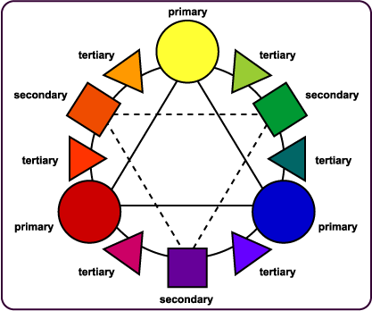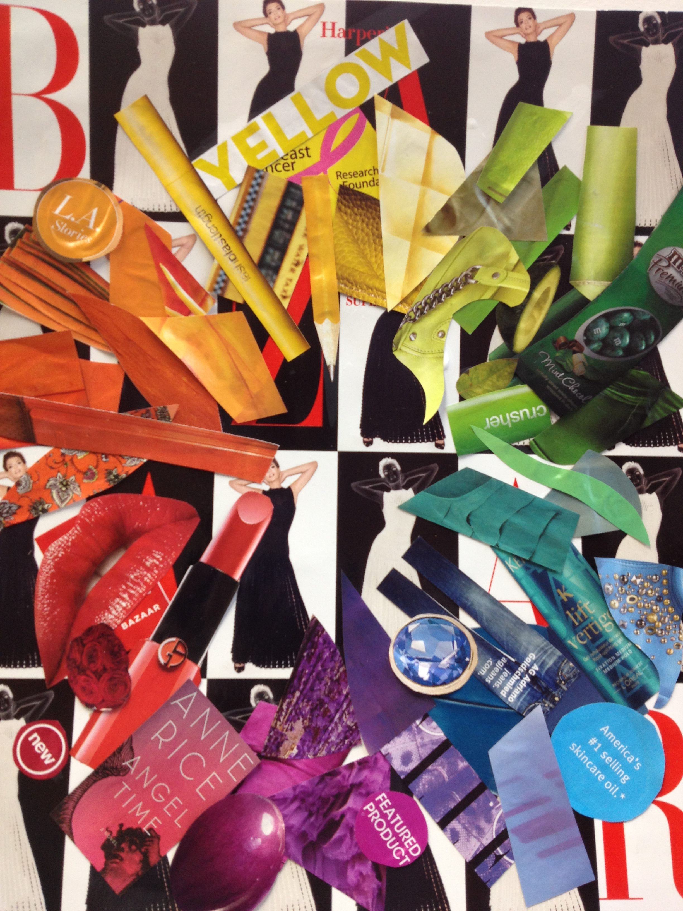

The third day is intermediate colors only, clip five or more examples of each color and glue them down in the correct placement. Above is an example of the color wheel and my finished work.

